Sophie Laggan
Research Fellow, Science Communication Unit and Air Quality Resource Management Centre, University of the West of England
Qualifications: Level 3 Award in Community Organising, 2018 Active Citizen, British Council, 2017 MSc Social Ecological Resilience for Sustainable Development, 2016 BSc Environmental Science, 2010
Nationality: Irish | Languages: English (mother tongue); learning Spanish
Profile
Sophie Laggan is a Research Fellow in the field of climate change communications, participatory methods, and community development. She has spent the last four years supporting or leading on the evaluation of large-scale participatory research projects, in addition to coordinating projects and conferences, engaging with public and professionals, including the delivery of science communication training, leading on digital communications, and developing dozens of educational materials in the area of sustainable development and climate action. With a research masters in Sustainable Development, she is thriving in her role at UWE Bristol and keen to take her enthusiasm and skillset into the next job that presents itself. The projects she has worked on include the Wellcome-Trust funded Our City Our Health, Horizon 2020 citizen-led air pollution reduction projects ClairCity (689289) and WeCount (872743), the WECA-funded DETI Inspire programme and the food projects of Bristol Aging Better, funded by the National Lottery. Most recently, Sophie was successful in a bid she submitted for co-developing Youth Climate Communications materials and training with young people. Previously, she has worked in science publishing, environmental journalism and most recently food sustainability. This latter venture saw her as Director of Bristol Food Network, managing its food waste work stream for the city’s Going for Gold submission to Sustainable Food Places, coordinator of the Bristol hub of Food Cycle, and food campaigner and event organiser. Sophie is team player, working with colleagues and stakeholders across Europe to build partnerships and deliver high quality project outputs that nudge us along the path to sustainability. All the while she keeps one foot firmly in the community to ensure those most impacted by development have a say in decision making.
Key skills/areas of technical expertise
- More than 10 years working in the environmental sector
- 5+ years’ experience coordinating or supporting large-scale participatory research projects for sustainability (e.g., citizen science and deliberative democracy)
- 3+ years evaluating research and public engagement projects
- Networking and relationship building
- Grassroots community organising and campaigning
- Graphic communications, ranging from infographics to reports, project newsletters and schools’ materials (using Canva and Adobe)
- Qualitative and quantitative social science skills (including surveys, interviews, focus groups, NVIVO and SPSS analysis, report and paper writing)
- Facilitator and educator, with experience delivering sessions to ages ranging from 9-90+
- Proficient at Microsoft Word, Excel, Teams and PPT
Selection of Project Experience
- 2016-2018 Project Coordinator, Our City Our Health
- 2018-2019 Event Coordinator, SciComm SouthWest
- 2018-2019 Lead Evaluator, Bristol Aging Better
- 2018-2019 Communications Officer, ClairCity
- 2019-2021 Research Associate, WeCount
- 2021-2022 Research Fellow, DETI Inspire, CCC-Catapult and Homes
- 2021-2022 Project manager, Youth Climate Communications
Career History
- 2011 Environmental journalist, The Ecologist
- 2012 Communications intern, Oxfam
- 2012-2014 Editor, Research Media
- 2015-2016 Director and Researcher, The Schumacher Institute
- 2016 Director, Bristol Food Network
- 2016-2021 Research Associate, UWE Bristol
- 2021-2022 Research Fellow, UWE Bristol
A selection of papers and reports
Fogg-Rogers, L., Hayes, E., Vanherle, K., Pápics, P.I., Chatterton, T., Barnes, J., Slingerland, S., Boushel, C., Laggan, S. and Longhurst, J., (2021). Applying Social Learning to Climate Communications—Visualising ‘People Like Me’ in Air Pollution and Climate Change Data. Sustainability, 13(6), p.3406. URL: https://www.mdpi.com/2071-1050/13/6/3406
Sardo, M., Laggan, S., Boushel, C., & Fogg Rogers, L. (2020). Citizen-led air pollution reduction in cities (ClairCity) Final evaluation report. European Union’s Horizon 2020 research and innovation programme. Available from https://uwe-repository.worktribe.com/output/6017473
Laggan, S., Beardmore, A., & Jones, M. (2020). Older people and community-supported shared meals in Bristol: Evaluation report on Bristol Ageing Better projects Talking Tables and Bristol Meets the World. Bristol Ageing Better. URL: https://bristolageingbetter.org.uk/userfiles/files/BAB%20food%20evaluation%20report%20-%20October%202020.pdf
Laggan, S. (2016). The power within social-ecological transformations: a case study of Bristol's food system, UK. (Masters’ thesis). URL: http://su.diva-portal.org/smash/record.jsf?pid=diva2%3A941531&dswid=-9232
A selection of digital communications materials
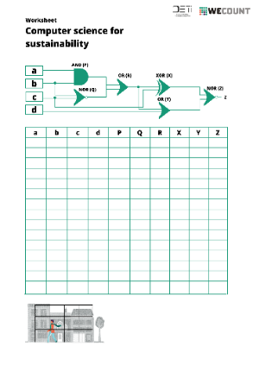
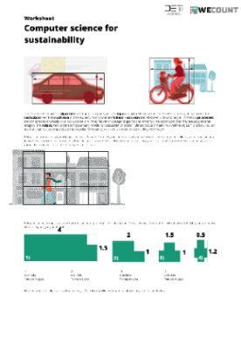
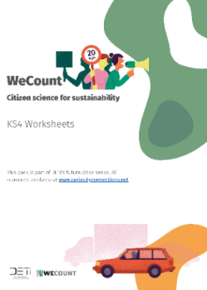
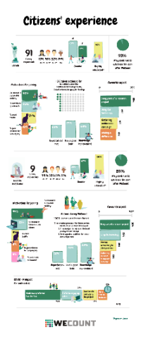
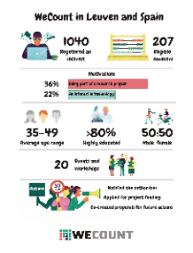
Graphics for WeCount evaluation report

Curriculum-linked educational materials produced and designed by Sophie for WeCount.

